Step 1: Create my React Project using Vite

|  |
| --- |
| npm create vite@latest  npm install  npm run dev |

https://www.youtube.com/watch?v=QdTHUv79EZc

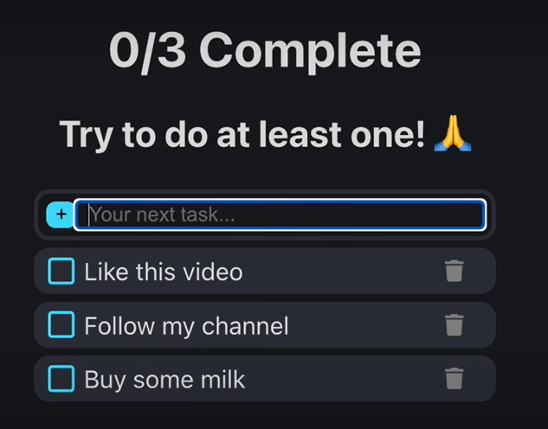

------------------------------------------------------------------------------------------------

Step 1: I need to code the interface

*The very first thing that I need to do here is to code my user-interface. My user-interface is what the user is able to interact with, so its basically what the user sees on their screen when they interact with the application. In order for the user to interact with the user-interface, they need to interact by either clicking or seeing something change on the user interface elements.

*So the very first thing that I need to do here is to break down the user-interface elements that I see on my screen. And I will break down all of these user-interface elements into a <div> , so what a <div> allows me to do is to group common user-interface elements and also to separate my user-interface elements.

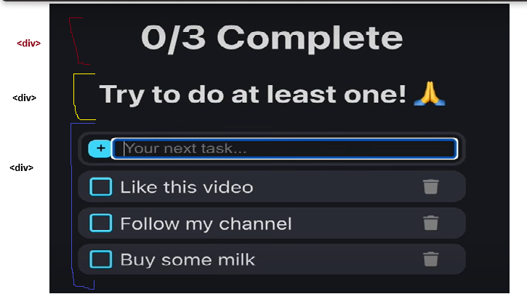

*So just by looking at the interface I can tell that I need to have 3 divs. So what the div’s allow me to do is that they allow me to have different sections in my code.

------------------------------------------------------------------------------------------------

<div> 3

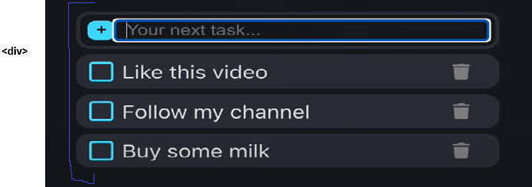

1. The very first thing that we need to notice about <div> 3, is that this aarea contains an input field. So we have a field where the user is able to provide us with input. And this means that we must have an <input> tag.

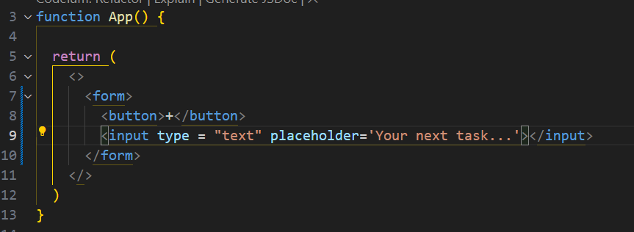

*So what I have done here is that I have created 1 component of my user-interface. But I have created it inside of my main function because I needed to test it, so that I see that it works and it work well, what I need to do is to move it to a its own file, that means that I need to create it as a component. And the name of this component is: TaskForm.jsx

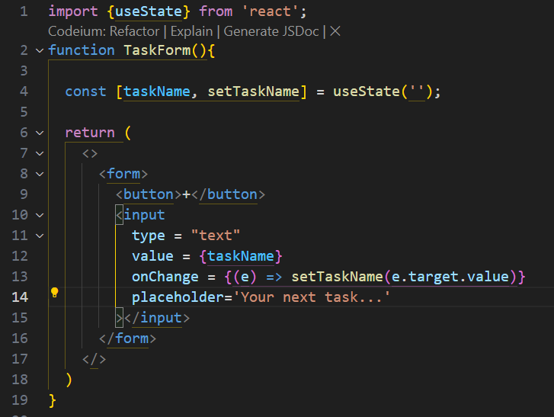

*So what we have done here is to code the functionality that allows us to take the “text” user input (e ) that the user gives us and then pass this input into the state variable that we have created.

------------------------------------------------------------------------------------------------

Now we need to design the second component. If we look at the second part of the component design, we have a checkbox and we have some text next to the checkbox, a checkbox is an input element, so we have to create an input element and then for the type = “checkbox”

------------------------------------------------------------------------------------------------